Date

Client name/address

Dear Mr./Ms. Client:

I am writing to confirm our meeting on [enter date of meeting] at [enter time of meeting]. I have enclosed a parking pass and directions to the Duke Law School Clinics. You can scan the parking pass at the gated entry to our parking lot. If the parking pass doesn’t work, ring the buzzer at the gate and let the person know you are here for a meeting with the Duke Law Clinic. They should let you in.

Once you get into the lot, there is a designated clinic parking spot close to the law school building at the end of a long sidewalk. The spot is marked with a small, blue sign. If that parking spot is taken, you may park anywhere, but make sure your parking pass is displayed on your dashboard.

To get to our office from the parking lot, take the long sidewalk in front of the clinic parking spot. Follow that to the building. There is a glass door at the end of the sidewalk. The Clinic is on the second floor, one flight up. If you prefer, there is also an elevator.

I look forward to meeting you on [enter meeting date]. Please let me know if you have any questions about visiting the Clinic or the [indicate any paperwork client should bring] that I have asked for. I can be reached at (919) 613-7169.

I look forward to working with you.

Sincerely,

[Student name]
Certified Law Student
Under the Supervision of
[supervising attorney name]
Supervising Attorney

Enclosures: Directions to the Duke Law Clinics
Parking Pass
DIRECTIONS TO DUKE LAW CLINICS

The Duke Law School Clinics are located on the second floor of Duke Law School, corner of Science Drive and Towerview Road on the Duke University Campus. The street address is 210 Science Drive, Durham. This is not marked on the building. See below for directions from Duke Hospital, Raleigh, and I-85.

The phone number at the Duke Law Clinics is 919-613-7169

Entering the Law School parking lot and building: If you have a parking pass, scan it at the gate. Otherwise, press the button and state that you are visiting the Duke Law Clinics. You may park anywhere in the lot, although there is a designated space near the building just past the stair opening. Follow the long sidewalk along the side of the building and enter. You may take the elevator or walk up the stairs to the second floor. The Duke Law Clinics are through the glass double doors.

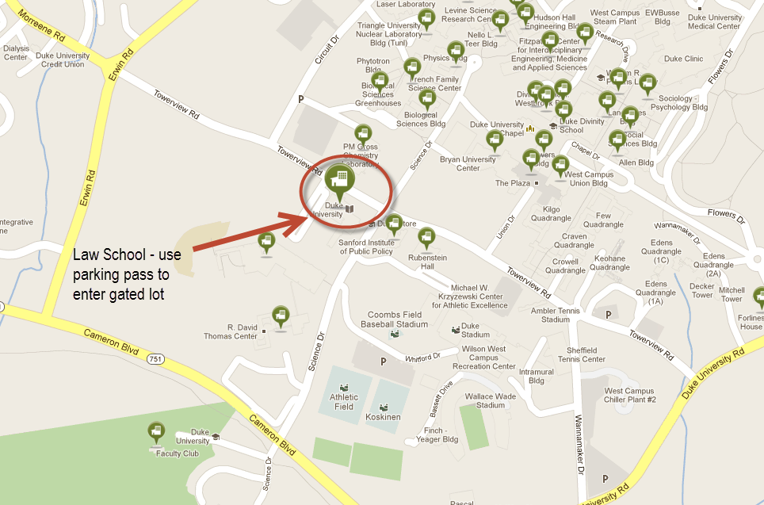

From Duke Hospital on Erwin Road: With the hospital on your left, continue west on Erwin Road to the traffic light at Morreene Road (on right) and Towerview Road (on left). Turn left onto Towerview. Pass the stop sign, then look for a gated lot on your right. (If you get to Science Drive, you have gone too far.) Turn into the lot and stop at the gate. See instructions above for entering the Law lot and building.

From Raleigh via the Durham Freeway (147): Take I-40 to NC147. Follow NC147 to the exit for US15-501 South. Once on US 15-501 South, immediately take the exit for Morrene Road. Turn left onto Morrene Road. Follow Morrene across Erwin Road, where Morrene becomes Towerview Road. Pass the stop sign, then look for a gated lot on your right. (If you get to Science Drive, you have gone too far.) Turn into the lot and stop at the gate. See instructions above for entering the Law lot and building.

From I-85 North - From Hillsborough, Greensboro, Charlotte: Take I-85 North to the exit 172 for the Durham Freeway, NC 147. Shortly after this exit, take the exit for 15-501 South. Once on US 15-501 South, immediately take the exit for Morreene Road. Turn left onto Morreene Road. Follow Morreene across Erwin Road, where it becomes Towerview Road. Pass the stop sign, then look for a gated lot on your right. (If you get to Science Drive, you have gone too far.) Turn into the lot and stop at the gate. See instructions above for entering the Law lot and building.

From I-85 South -- Oxford, Henderson, Virginia: Take I-85 South to US15-501 South. Exit 15-501 at Morreene Road. Turn left onto Morreene Road. Follow Morreene across Erwin Road, where it becomes Towerview Road. Pass the stop sign, then look for a gated lot on your right. (If you get to Science Drive, you have gone too far.) Turn into the lot and stop at the gate. See instructions above for entering the Law lot and building

