chapter seventeen
Patents: Hopes, Fears, History & Doctrine
1.) Hopes and Fears
For many people, patent law represents everything that is necessary, inspiring and worrying about intellectual property.
Necessary because there are lots of areas in which the monopolies granted by patent law seem to work: they get us innovations—innovations that save, change or enrich lives. Anyone reading this who has a friend or loved one who is alive—or functional—now because of a patented drug can explain what this means. Let us pause to contemplate this fact, a particularly luminous one in the time of a pandemic. Social institutions that work, even episodically, are to be cherished. A lot of things in life, perhaps most, do not work. Functionality should not be taken for granted.
Inspiring because the patent system represents an ideal that is deep in the Anglo-American psyche: It is not just the idea of the inventor in the garage—the little guy with an innovative idea who can change the world and give up his or her day job to work on other innovations. While that is an appealing vision, it is one that is increasingly a marginal part of the patent system, which is dominated by corporate research and development. It is the idea that we can couple the essential force of state funded research—basic science—with that of decentralized innovation through a market. The authors of this book admit to being believers in this idea. They understand it can be—and is frequently—misused. They realize that much innovation will happen without the inducement of patents—driven by ego, prestige economies, altruism, serendipity and good old fashioned competition. They know that the ideal of decentralized innovation hardly represents what happens in a company defensively patenting obvious technological steps, or a “non-practicing entity” (popularly known as a patent troll), wielding dubious patents to the innovators. They admit it will play no role in overcoming the difficulties in getting the global poor access to essential medicines—we need other tools for that. And this ideal bears little resemblance to the contortions that drug companies go through to “evergreen” their patents through trivial improvements. But they still think the patent system can be a vital part of our society’s toolkit for the pursuit of innovation. Not everyone does.
Worrying for several reasons. First, Macaulay’s reasons—elaborated in Chapter 10. “I believe, Sir, that I may safely take it for granted that the effect of monopoly generally is to make articles scarce, to make them dear, and to make them bad.”
We talked in Chapter 1 about the losses imposed by intellectual property. The passive losses are represented by the people who would pay above marginal cost but who are priced out of the market when the intellectual property right gives the owner the ability to set a (constrained) monopoly price. (Constrained because, if ibuprofen is under patent and clearly is the best drug for me, there is still a price point at which I will buy aspirin or acetaminophen instead.) But the patent allows its owner to charge far above marginal cost and that is not a bug, it is a feature. The people who would have paid above marginal cost, but who cannot afford the price charged by the patent holder, are priced out of the market. Access-to-medicines activist Jamie Love, of Knowledge Ecology International, has a particularly powerful presentation in which he puts up the standard monopoly price graph, with its grey shaded triangle of social loss in the center. “In economics” he says, “we call this ‘dead weight social loss.’ With essential medicines we call it ‘dead people.’” That point, too, is particularly luminous in the time of a pandemic,
Love’s point is deliberately inflammatory but it is worth thinking about because it cuts both ways. Without the patent, it is quite possible we would not have the medicine at all—think about what that means for all those who might be saved by it. But the patent scheme—which accepts a limited-duration ability to charge above marginal cost as the social price for incentivizing the innovation in the first place—imposes a heavy burden, one that is measured in human as well as dollar terms. Where the passive loss involves not getting the cool feature on your new phone or the best material for your 3D printer until it goes off-patent, perhaps we can live with it. But as the drug example shows, patent law has consequences, both good and bad, that mean that policy makers, judges and citizens think about its costs differently than they do with copyright. And let us be clear here, these are the costs (and benefits) of the patent system if legislated and implemented perfectly. The passive or static losses caused by the patent monopoly are part of the design of the system. If the patent system is properly implemented, those losses are more than made up for by the innovations society receives, innovations it would otherwise not get. This critique does not speak to an imperfect patent system, in which poor patents are granted or patent holders are able to game the system or extend the lifetime of the patent beyond its correct term. The losses imposed by that system have no such compensating social gain.
Those are the passive losses. The active or dynamic losses are those imposed on future innovation. Here the problem is not that consumers are priced out of the market for goods for which they would pay above marginal cost. The question is the effect of existing patents on the next innovator. First, again assume that the patent system is operating perfectly—only truly novel, non-obvious and useful innovations are granted patents, the patents are clear, the required disclosure in the patents is adequate to understand the technology and the boundaries of the right that has been granted over the technology are well understood. In such a situation subsequent innovators can easily draw on the abstract knowledge contained in the patents, while avoiding trespassing on the actual patent—unless they choose to license it, which we presume they can do in an efficient and relatively friction-free market. In this world, there is a dynamic cost to patents but it is more than outweighed by the patent system’s dynamic gains.
For simplicity’s sake, imagine a patent system with only one technology—windscreen wipers—and one patent. Mr. First has patented the variable speed windscreen wiper. Since rain varies in intensity, this is truly a useful innovation. Mr. Second is inspired by this invention. He reads First’s—statutorily required—disclosures of how the variable speed wiper works. (Note that the promise of the patent, and its 20 years of exclusivity, has made First abandon the trade secret regime, on which he might have relied, and instead has forced him to explain his innovation to the world.) But Second believes that the American driver should not have to engage in the massive labor of turning a dial to select what speed the wipers move at. His idea is to couple the variable speed wiper with a water sensor that would automatically detect the level of rain and adjust wiper speed accordingly. Let us assume for the moment that this counts as both novel and non-obvious. One of patent law’s interesting features is that Second can patent his compound invention without First’s approval. Now both patents sit in the system. Second cannot market, or license, his innovation without First’s approval—First’s patent would block that. But neither can First arrogate to himself Second’s marginal improvements. The patent system sets up an incentive for them to bargain together in order to allow the commercialization of this new, compound, innovation.
What were the dynamic losses? Was a cost to Second (and to society) imposed by First’s patent? Yes, in the obvious sense that Second will need to license First’s patent and this will increase the marginal cost of the compound innovation. But—assuming again that the patent system is operating properly—without First’s patent we would not have had Second’s innovation to begin with. The dynamic benefits are greater than the costs. The design of the system—requiring disclosure and not requiring “permission” to create subsequent compound innovations, though permission would be required to practice them—is set up precisely with that in mind.
Now let us introduce some reality into the model. What if the system is not operating properly? What if the second innovator finds that, rather than “standing on the shoulders of giants,” he is being sucked into a quicksand of patent claims? Does his research and development budget get eaten up trying to deal with vague, poorly drafted and improperly granted patents that block the road to the next innovation? What data do we have on how the patent system is functioning? Unfortunately, much of the recent empirical studies of the patent system provide a worrying picture. In some areas of technology, far from being an encouragement to progress, patents actually seem to be imposing a drag on innovation.
During the past five years, academic researchers have published more than two dozen empirical studies on patent litigation and its economic impacts. These studies have been conducted by researchers with diverse views and using different methodologies. The preponderant economic picture presented is that patent litigation now imposes substantial costs, particularly on small and innovative firms, and that these costs have tended overall to reduce research and development, venture capital investment and firm startups. By most tallies, the majority of lawsuits are now filed by so-called “patent assertion entities,” popularly known as “patent trolls.” Estimates based on surveys of Form 10-K filings and stock prices find that patent litigation has been costing firms tens of billions of dollars per year since 2007. Startups and venture-backed firms, especially, report significant operational impacts from “PAE” lawsuits in survey-based studies. One analysis finds that the more R&D a firm performs, the more likely it is to be hit with a patent lawsuit. Another study associates lawsuits from PAEs with a decline of billions of dollars of venture capital investment; another found that costly lawsuits caused publicly listed defendant firms to substantially curtail R&D spending.
Empirical scholarship, and a great deal of practical experience, seems to suggest that in some areas of strongly cumulative innovation over particular types of technologies—software, for example—this is exactly what is happening. We tend to think about technological development as involving a limited number of “inputs” that can be clearly defined in advance—the innovator has to decide whether or not the new kind of spring patented by another inventor is worth licensing for use in his next-generation mousetrap. But with developments in complex technologies, the reality is much more complicated. Estimates for how many patents “read on”—that is, are potentially implicated by—a smart phone, range from thousands to tens of thousands. Everything from the touchscreen, to the interface, to the software, to the hardware, to the way it works with networks may be covered by hundreds, even thousands of patents. And critics argue that those patents are vague and many of them are bad—meaning they are patents that should not have been granted; the technology is not truly novel or non-obvious. Imagine wandering through a minefield whose mines were painted by an impressionist—their boundaries are vague and overlapping and many of them should not be there in the first place.
In this situation it may be impossible to know what property rights your new technology is infringing, and which of those property rights would be upheld in a trial. Instead, firms have two options. First, they can “defensively” patent—going beyond genuine innovations to claims that their lawyers secretly think are pretty weak. Having accumulated their own war-chest of good and not so good patents, they can cross-license with their competitors. I agree to license my arsenal of good and dubious patents to you, if you will license your similar arsenal to me. Second, if cross-licensing does not work, they can use their arsenal for so-called “Mutual Assured Destruction.” The patents are both so many and so vague that all parties know they are infringing at least some patents held by a competitor. As in the cold war, the threat of mutual destruction is supposed to hold back the missiles, or in this case, the lawsuits. Sometimes, of course, the threat is not enough and a controversy breaks out anyway—as in the smartphone patent wars—setting off an orgy of lawsuits which is excellent for future patent lawyers but of dubious social value otherwise.
The problems in such a system are obvious. The need for a huge arsenal of defensive patents will be a serious barrier to entry; IBM and Dell can cross-license. What of the upstart innovator? Legal costs will be high—both offensively and defensively. The “picket fences of the mind” will be poorly drawn, leading to under-development of technologies, or over-investment in legal precautions. And the threat of mutual assured destruction only works against genuine competitors—the troll (or “non-practicing entity”) need not fear retaliatory suit, because it produces nothing. It is not infringing any patents because its only industrial outputs are the threatening letter and the lawsuit. But—just to be clear—these are costs that occur only when the patent system malfunctions. If patentable subject matter is appropriately delineated, if patents are only granted for genuinely novel, nonobvious and useful technological innovations that we would not get otherwise, if they are clearly drafted and defined and if all parties in a marketplace have the ability easily to license the ones they need, then these problems—unlike the problem of pricing people out of the market—can be avoided.
Our sense of the current patent system is that some parts of it—for example, patents over small molecule drugs—have fewer problems with vague and bad patents. That does not mean they are free from abuse. The issues of “ever-greening” patents, of vexatiously suing, or buying off the manufacturers of generic drugs, are well known. Still, the person patenting Tagamet and the person patenting Viagra both get a patent over something pretty clearly defined. They know what they have, they know what would infringe it and they do not need thousands of possibly patentable inputs to create their innovation. But patents over software, complex biotechnology or technologies such as smartphones may represent a very different reality. Thus, the problems we have just described are not evenly distributed throughout the patent system. If I am applying for a patent over a drug, the standards for patentability seem relatively well-defined, if subject to gamesmanship. The boundaries of the resulting patent are also clear. With the smartphone patents we mentioned earlier, the opposite is true.
Correspondingly, patent litigation is not evenly spread out. To be sure the question of how to classify patents is subject to dispute. Nevertheless, a substantial number of patent scholars agree that software and business method patents are far more likely to produce litigation than any other kind, perhaps because of their vague boundaries and unclear claims or perhaps because they were acquired with the goal of extracting a toll from companies that are making and doing things. Or both. Of course, it could be that this assessment is wrong and that there are many more business method pirates and software patent violators out there relative to those who would violate drug or chemical patents. Yet this seems unlikely and when we get to the discussion of patentable subject matter, you will see that several members of the Supreme Court believe there is cause for concern.
How do these very general comments about the necessary, inspiring and worrying aspects of patents bear on the actual doctrines of patent law? Just as the bounds, exceptions and limitations of trademark law and copyright law were built around our goals, hopes and fears in each of those fields, so too with patent. The patent term is short as compared to copyright and trademark—20 years rather than life plus 70, or perpetuity for trademark, so long as the mark continues to be used. The passive and dynamic losses are thus limited in time. The public domain awaits. The patent system explicitly allows follow-on innovators to build on the contributions of existing patent holders (though it denies them the right to practice that compound innovation without mutual consent). Patents are subject to—supposedly rigorous—examination procedures. Unlike a copyright which exists as soon as the original expression is fixed in material form, to get a patent one must satisfy a patent examiner that the innovation is worthy of a patent. It is on the last feature that we will concentrate in this book. We will look at four such architectural features of the patent system, four hurdles that someone seeking a patent must clear.
- The limitations on patentable subject matter: what can and cannot be patented
- The requirement of utility—that patents must be over useful innovations
- The requirement of novelty
- The requirement of non-obviousness.
Each of these limitations is designed to help minimize some of the concerns about patent law, while maximizing its social benefits. In a properly functioning patent system, goes the hope, we will grant patents that are over technologies that are important but not so fundamental as to give a monopoly over an abstract idea or law or product of nature in a way that would impede subsequent innovation. (Subject matter.) We try to make sure that the innovator has actually given society an invention that is usable now rather than trying to patent a line of research that has not yet been reduced to practice. (Utility.) We try to make sure that these innovations do not exist somewhere already. (Novelty.) If they do, then society does not need to pay the monopoly price for them, nor do subsequent innovators need to labor to get around the patent. Finally, we require that patentable innovations be non-obvious. If this is the next step in a mundane march of technology, then society likely would have received the innovation without paying the monopoly price. (Non-obviousness.) Thus the limitations we will explore in the next four chapters are, in a very real sense, our society’s attempt to maximize the benefits and minimize the active and dynamic losses imposed by patents. Whether in their daily application they actually do so is another question.
Finally, what about costs? It is hard to estimate both public and private costs. The data is hard to come by. One often needs to use indirect studies that rely on effects on stock market prices and the like. One 2013 study, which only reaches data until 2009, attempted to measure private costs of patents (for example, of litigating a patent if one was sued), and to set those against the benefits provided to the patent holder by patent “rents”—the return to the patent holder provided by the statutory monopoly. The worrying aspect of this data is the way that litigation costs outpace patent “rents.” The cost of litigation appears to be dwarfing the amount derived from the patent. What if the total return to all patent holders is less than the costs being imposed on all others by dealing with the patent system? Are we getting enough incentive “bang” for our administrative and litigation “buck”? Let us assume rational actors, who would rather license a patent if they believe they are legally required to and that a court would so hold. Yet in a world full of vague or bad patents, those actors would be unable to make those rational decisions accurately. Is the inventive stimulus of those patent rents being swallowed up by the costs imposed on outsiders by the system?
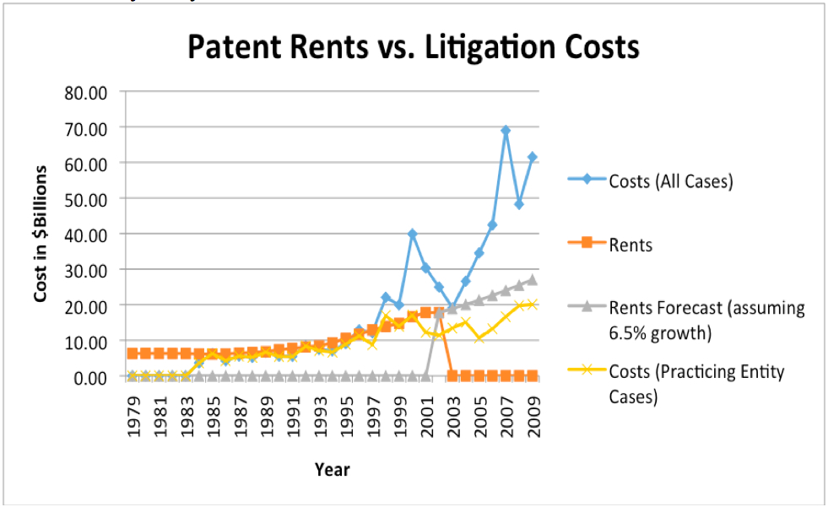
Notice a number of things. Patent litigation costs increased sharply. The proportion of those costs imposed by practicing entities has only a mild upward trend. In other words, the costs being imposed by those who do not use the technologies they are attempting to license, “patent trolls” is the common term, have increased dramatically. As of 2009, the study showed total patent litigation costs far outweighing the rents received by patent holders. This is a system in which patent lawyers will be well compensated. It is unlikely it is one that is socially desirable.
However there is some reason to believe that things may be changing. The chart above ends in 2009. On the following page is a more up to date chart of cases filed in district courts over copyright, patent and trademark issues. We have highlighted on the time axis the dates of some of the legislative interventions and landmark cases that we will discuss later.
Patent cases start at about 1800 a year in 1996, but start to accelerate steadily, surging between 2002–2006 and 2011–2014. Then filings begin to decline. It is hard to determine the exact causes for the drop, but they could include:
i.) The America Invents Act of 2011, which introduced a number of reforms, including the possibility of lower cost, post-grant patent challenges;
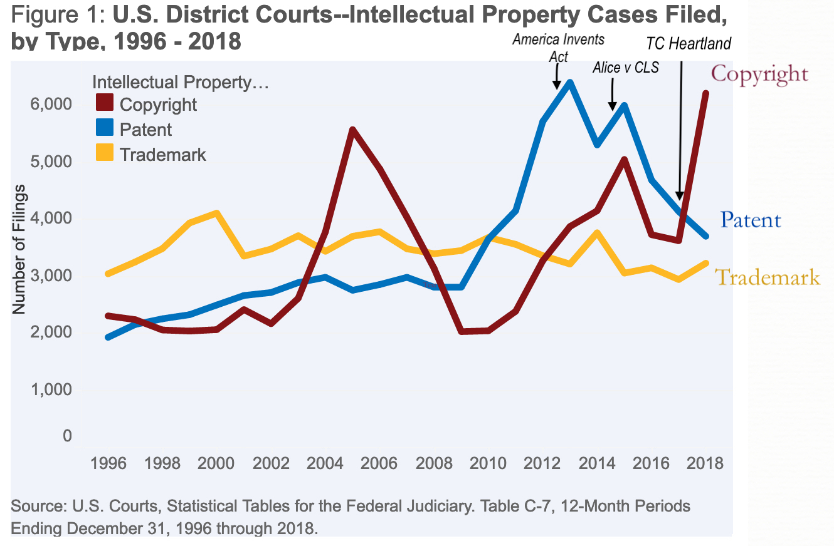
ii.) Alice v. CLS, a 2014 Supreme Court decision which raised patentable subject matter standards over abstract ideas implemented by a generic computer. That decision did not, as we will see later, cut down on the issuance of software patents, indeed they now amount to over 60% of all patents issued! It may however—at least temporarily—have curtailed some vexatious litigation.
iii.) T.C. Heartland v. Kraft Foods, a 2017 Supreme Court decision which clarified the patent venue rules in a way that denied many patent plaintiffs their favored venue: the Eastern District of Texas, which had accounted for up to third of all patent cases. The Eastern District’s pro patent judges and its “rocket docket” were particularly popular with “non practicing entities,” or NPE’s, less affectionately referred to as patent trolls. (In fact, it was so popular that Samsung built a community ice skating rink next to the town where the court is located, arguably to curry favor with potential local jurors.) The problems have not been solved however, and cases have started to edge up again. Ironically, the Western District of Texas is now a preferred destination. The troll phenomenon is not confined to patents. The surge in copyright cases in recent years is partly fueled by so-called copyright trolls.
2.) History
As with copyright law, our patent law has its roots in England, and in particular, in the effort to curtail monopolies. In response to the Crown’s use of royal privileges or “letters patents” to grant monopolies over certain industries, the English Parliament passed the Statute of Monopolies in 1624. This law nullified “all monopolies,” and restricted “any letters patents and grants of privilege” to a “term of fourteen years or under, hereafter to be made, of the sole working or making of any manner of new manufactures within this realm to the true and first inventor and inventors of such manufactures.” In other words, patents could only be granted for novel inventions, for a term of no more than 14 years.
Acting under its Intellectual Property Clause power, Congress passed the first US patent law in 1790. It was titled “An Act to promote the progress of useful Arts.” The term of protection was 14 years. The first patent was granted to Samuel Hopkins for “making Pot ash and Pearl ash by a new Apparatus and Process.” (Potash was an industrial chemical derived from potassium carbonate used to make glass, soap, dyes, and other products.) An image of this patent is below. It is signed by George Washington, Thomas Jefferson, and Attorney General Edmund Randolph.
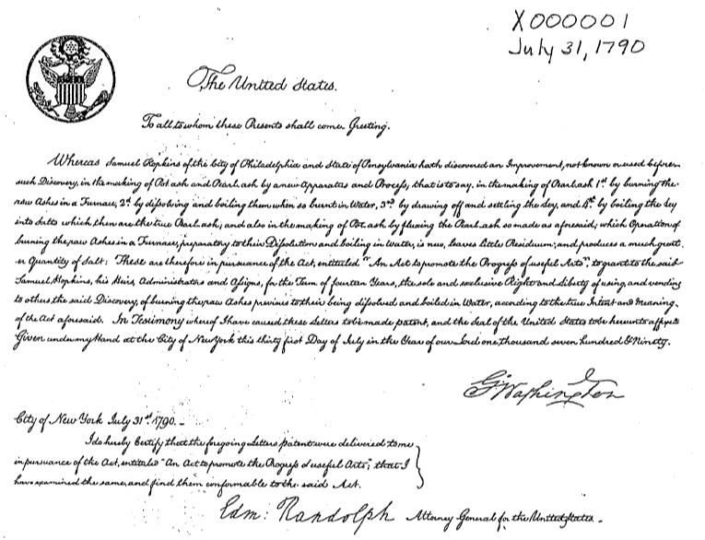
You have already read Thomas Jefferson’s writings about patent law in Chapter 2 of The Public Domain. Under the 1790 law, Jefferson (as Secretary of State) was one of the three government officials tasked with deciding whether or not to grant patents. This proved unworkable, and the Patent Act of 1793 did away with this early patent examination process and made it easier to receive a patent. This led to patents over inventions that were not necessarily novel or useful, and increased patent litigation. The Patent Act of 1836 then reinstated a formal examination procedure by creating an official Patent Office and providing funding for professional patent examiners. The basis for current patent law—and the focus of this casebook—is the Patent Act of 1952, along with recent amendments made by the 2011 America Invents Act (discussed below).
In 1982, Congress created the United States Court of Appeals for the Federal Circuit, which has exclusive jurisdiction over patent-related appeals. Most commentators have seen the Federal Circuit as a more pro-patent court than the diverse Circuit Courts whose jurisdiction it assumed. (This of course might be no bad thing if prior courts had been under-protecting patent holders). Early empirical work showed that the Federal Circuit was considerably more likely to find patents valid. See John R. Allison and Mark A. Lemley, Empirical Evidence on the Validity of Litigated Patents, 26 American Intellectual Property Law Association Quarterly Journal 185 (1998). Henry & Turner’s work on the effects of the Federal Circuit’s strong presumption of patent validity reinforced that finding 8 years later. Matthew Henry & John Turner, The Court of Appeals for the Federal Circuit’s Impact on Patent Litigation, 35 Journal of Legal Studies 85 (2006). Scholars have also focused on the insularity of the Federal Circuit and the way in which its tight connections to the patent bar, and its lack of exposure to the views of competing Circuit courts, may reinforce a protectionist mindset. Our colleagues Arti Rai and Stuart Benjamin found, in a nice piece of understatement, that “[t]he behavior of the Federal Circuit was arguably consistent with standard accounts of capture of regulatory processes by well-represented interest groups.” Stuart Minor Benjamin & Arti K. Rai, Fixing Innovation Policy: A Structural Perspective, 77 Geo. Wash. L. Rev 1, 17 (2008). Landes and Posner’s fascinating review and extension of the statistical literature on the Federal Circuit tends to confirm these findings, suggesting that the court’s rulings have led to a proliferation of weak and vague patents, the litigation outcome of which is uncertain. William M. Landes & Richard A. Posner, The Economic Structure of Intellectual Property Law 335-353 (2003). Whether or not that result is in the interests of the patent bar, and we tend to be skeptical of the more overt forms of capture-theory, it is socially problematic. Others have argued that the Federal Circuit’s jurisprudence is not only pro-patent but increasingly formalist, disconnected from the constitutional purposes the patent system is supposed to serve. John R. Thomas, Formalism at the Federal Circuit, 52 Am. U. L. Rev. 771 (2003). The books cited earlier by Bessen and Lerner collect many other examples.
Both the number of patents issued and the number of patent cases filed has more than tripled in recent decades. Earlier we included a graph that showed the rise in patent cases filed in District Courts from 1,165 in 1990 to 5,163 in 2012. In 2013, a private data source suggests, the number of cases rose 25 percent to a record high of 6,500, and the number of patents granted rose 7 percent to almost 300,000 patents. PricewaterhouseCoopers, Patent Litigation Study (July 2014). The role of corporate ownership has also expanded. As we mentioned at the beginning of the chapter, over time, patents have gone from the realm of the “lone workshop tinkerer” to that of “large-scale corporate R&D”: “in 1885, only 12 percent of patents were issued to corporations. Slightly more than one hundred years later, the proportions had completely reversed: by 1998, only 12.5 percent of patents were issued to independent inventors.” Robert P. Merges, One Hundred Years of Solicitude: Intellectual Property Law, 1900–2000, 88 Cal. L. Rev. 2187 (2000).
3.) Patent Basics
You have already learned a great deal about trademarks and copyrights. Patents are distinct in a number of ways. First, they are more difficult to obtain. Inventors can only secure a patent through a prosecution process before the United States Patent and Trademark Office (PTO), during which they need to convince the patent examiners that they have met the many requirements for patentability (summarized above). This process can be time-consuming and expensive. While times vary considerably depending on the subject matter and complexity of the application, studies have shown that the average duration of the examination process is between 2 and 3 years. See the USPTO Performance and Accountability Report: Fiscal Year 2013 (showing an improvement of total pendency to 29.1 months); John R. Allison and Mark A. Lemley, Who’s Patenting What? An Empirical Exploration of Patent Prosecution, 53 Vand. L. Rev. 2099 (2000) (showing an average of 2.77 years). As students entering patent practice will discover, patent application costs can be significant. After a patent is issued, however, the patent holder enjoys a broad right to exclude others from making, using, offering for sale, selling, or importing the invention. In contrast to copyright law, there is no need to prove that the defendant “copied,” and independently creating or reverse engineering the invention is no defense.
On the other hand, the patent term is much shorter than that of copyright (life of the author plus 70 years) or trademark (potentially perpetual as long as the mark is continually used in commerce and paperwork is filed). Until 1995, the patent term lasted 17 years from the date that the patent was granted. The current patent term is 20 years from the date the application was filed. However, the current law tries to ensure that the patent holder will enjoy at least 17 years of post-grant protection by adding 1 day to the term for each day that it remains in prosecution after 3 years, as long as the delay is the fault of the PTO. § 154(b).
As we mentioned a moment ago, to obtain a patent, an invention must meet several requirements. It must consist of patentable subject matter, and be novel, non-obvious, and useful. §§ 101–103. The chapters that follow explore these requirements in detail. The additional requirement of disclosure is worth highlighting here. § 112. Patent protection not only provides incentives to innovate; its promise of exclusivity provides incentives to disclose valuable knowledge, rather than keeping it secret. A patent must describe the invention sufficiently well that any person skilled in the relevant art will be able to recreate and use it. This is a fundamental part of the patent bargain: in return for a broad 20-year grant of exclusive rights, the patent holder must disclose her technology so that others can benefit from it. This “promotes the progress” by ensuring that future inventors can build upon what came before them. The American Inventor’s Protection Act of 1999 added to the store of public information by requiring the publication of pending applications 18 months after the filing date, so that the knowledge in long-pending applications would not remain secret. § 122(b). (This requirement was introduced partly because other countries had a similar 18-month disclosure requirement, and it was thought to be beneficial. Applicants in the United States, however, have several exemptions from the disclosure requirement—for example, they can request secrecy if they are not intending to file in any countries or under any multilateral agreements that require publication after 18 months.)
3 a.) The America Invents Act
In 2011, Congress passed the America Invents Act (AIA). Its key provisions went into effect on September 16, 2012 and March 16, 2013. Thus, you are studying patent law during a transitional period in which you will have to deal with patents granted under both systems. That said, in those areas where the AIA did not change the law, Congress sought to maintain much of the pre-AIA statutory language so that existing case law would continue to offer guidance. The full provisions of the AIA are beyond the scope of this introduction, but two of its key changes are summarized below.
“Who’s on first?” One of the most sweeping changes in the AIA is a fundamental shift in how novelty and priority are determined.
Before the AIA, we had a first-to-invent system. Your invention was novel—that is, eligible for patent protection as the first such innovation—only if it was invented before anyone else invented the same thing. § 102(a)(pre-AIA). However, this provision was subject to an important caveat: even if you invented first, you could nevertheless lose “the right to patent” if you delayed too long before filing the application. § 102(b)(pre-AIA). (This is the statutory bar that disqualified inventions if they were already described in a printed publication, sold, or in public use for over a year before the application date.) Therefore, under pre-AIA law, novelty and priority initially turned on the date of invention, but patent eligibility could then be defeated based on the date of filing.
After the AIA, the key date across the board is the filing date. For all applications filed on or after March 16, 2013, the AIA implements a first-inventor-to-file system. Priority is now based on who filed first rather than who invented first. § 102(a)(post-AIA). However, that statement is subject to a vital limitation. The AIA did not repeal the requirement of novelty. You still are unable to patent an item that has been described in a printed publication, been on sale or available to the public. If on the day you file the patent application, none of those things is true, then your invention is considered novel vis a vis the prior art. This is subject to a 1-year grace period before the filing date during which a disclosure by the inventor (or a third party “who obtained the subject matter disclosed directly or indirectly from the inventor”) will not count against the claimed invention as prior art. § 102(b)(post-AIA). (This is a highly simplified description of the AIA’s new provisions, please refer to the full language for complete details. Of course, the language is not always entirely clear—there is already a difference of opinion among patent experts about the scope of the 1-year grace period.)
The second set of key changes involves expanded procedures for reviewing patents. As an example, under the AIA’s “post-grant review” provision, anyone can challenge the validity of a patent (or its claims) within nine month of its issue. § 321. The goal is to improve patent quality by providing better mechanisms to invalidate “bad” patents that should not have been granted.
3 b.) The PTO Application Process
An applicant can either begin by filing a complete application or a “provisional” application. § 111(b). The provisional route allows the applicant to file much simpler paperwork (it does not need to include a formal patent claim or an oath or declaration) and claim the earlier date as the effective filing date, so long as a full application follows within a year. It also allows the inventor to use the term “patent pending.”
It takes an average of over a year for a patent examiner to begin reviewing an application. (Like customer service calls, patent applications are processed in the order in which they are received.) The examiner will often raise objections based on prior art and a lack of meeting the patentability requirements. The inventor can then contest the objections or amend to application.
Patent applications are not set in stone. In addition to amending the application, an inventor who wants to make significant changes can file a new “continuation-in-part” application; the material carried over from the original “parent” application maintains its earlier (preferable) filing date, while newly added material is subject to the later filing date of the continuation. (As you might expect, both provisional applications and continuations are subject to strategic use by patent attorneys.) If an application covers more than one independent and distinct invention, then the PTO may require that a “divisional application” be filed. § 121. If the material in the divisional application can be properly traced back to the description in the original application, then it can maintain the earlier filing date.
After a patent is granted, it is published in the Patent Gazette, and enjoys a (rebuttable) presumption of validity. (There is no eventual incontestability, as there is in trademark law.) If errors were made in the patent, it can be “reissued” with corrections, though claims can only be enlarged within two years after the initial grant of the patent. § 251.
3 c.) Reading a Sample Patent
The best way to appreciate the “art” of patent drafting is to review one in detail. A sample patent is on the upcoming pages. It is one of many inventions by Stanford professor and serial inventor Alan Adler, the man who developed the Aerobie flying disc (the rubber and plastic ring that can fly a really long way). The patent is over the AeroPress, a coffee maker that attracts fanatical support as brewing the best cup of coffee of any available technology.
Look at the information on the first page. The name and address of the inventor provide notice of who to contact about the invention. Unlike copyright law, which allows employers to be considered “authors” if a work was “made for hire,” patent law does not substitute the employer for inventor. Even if the employer is by explicit assignment the patent holder, only the person who actually invented can be named as such in the application.
Next, notice the series of dates. See if you can tell how long the examination process took and when the patent will expire. As you can see, the inventor is required to list relevant “prior art” to help the examiner—and potential competitors—judge if the invention is truly novel and non-obvious.
Now look at the invention. Patent applications must contain a “specification”—a written description of the invention—and drawings, as relevant. (You can see a drawing on the first page, the other drawings have been omitted.) As you read through the upcoming chapters, think about whether you think this coffee press is novel and non-obvious. The specification is supposed to allow later inventors to build on the invention, or competitors to invent around it. Together with the claims, which we will discuss in a moment, the specification performs some of the same functions as the fixation requirement—it helps to fix the boundaries of the statutory monopoly. But as you can see, patent law requires far greater detail; its aim is greater precision in defining the limits of the right. As we will see later, this goal is not always achieved.
Now look at the actual patent claims on pages 2–3 of the patent. Claims provide an even more detailed delineation of the metes and bounds of the exclusive right. Patent drafters will try to make them as broad as possible, without sacrificing their validity to obviousness, or straying beyond patentable subject matter—which we will discuss in the next chapter. Claims 1, 12, and 14–16 are “independent” claims for various versions of the coffee or tea filtering press. These are deliberately broad. Read claim 1—what exactly does it describe? The other claims are “dependent” claims that refer back to the independent claims. These are narrower and will survive if the independent claim is invalidated, for example, for lack of novelty or for obviousness. Note that the claims use the term “comprising.” This is a deliberately “open” term of art meaning the patentee is claiming something novel, and that another coffee maker might infringe this patent even if it has additional features not present in the claims. The alternative “closed” term would be “consisting of”—this would mean that the patentee is only claiming the exact listed elements. In that case, another coffee maker with additional features would not infringe.

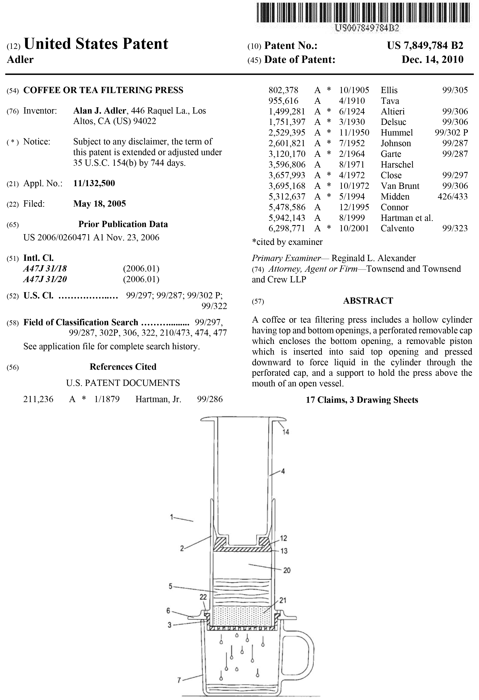

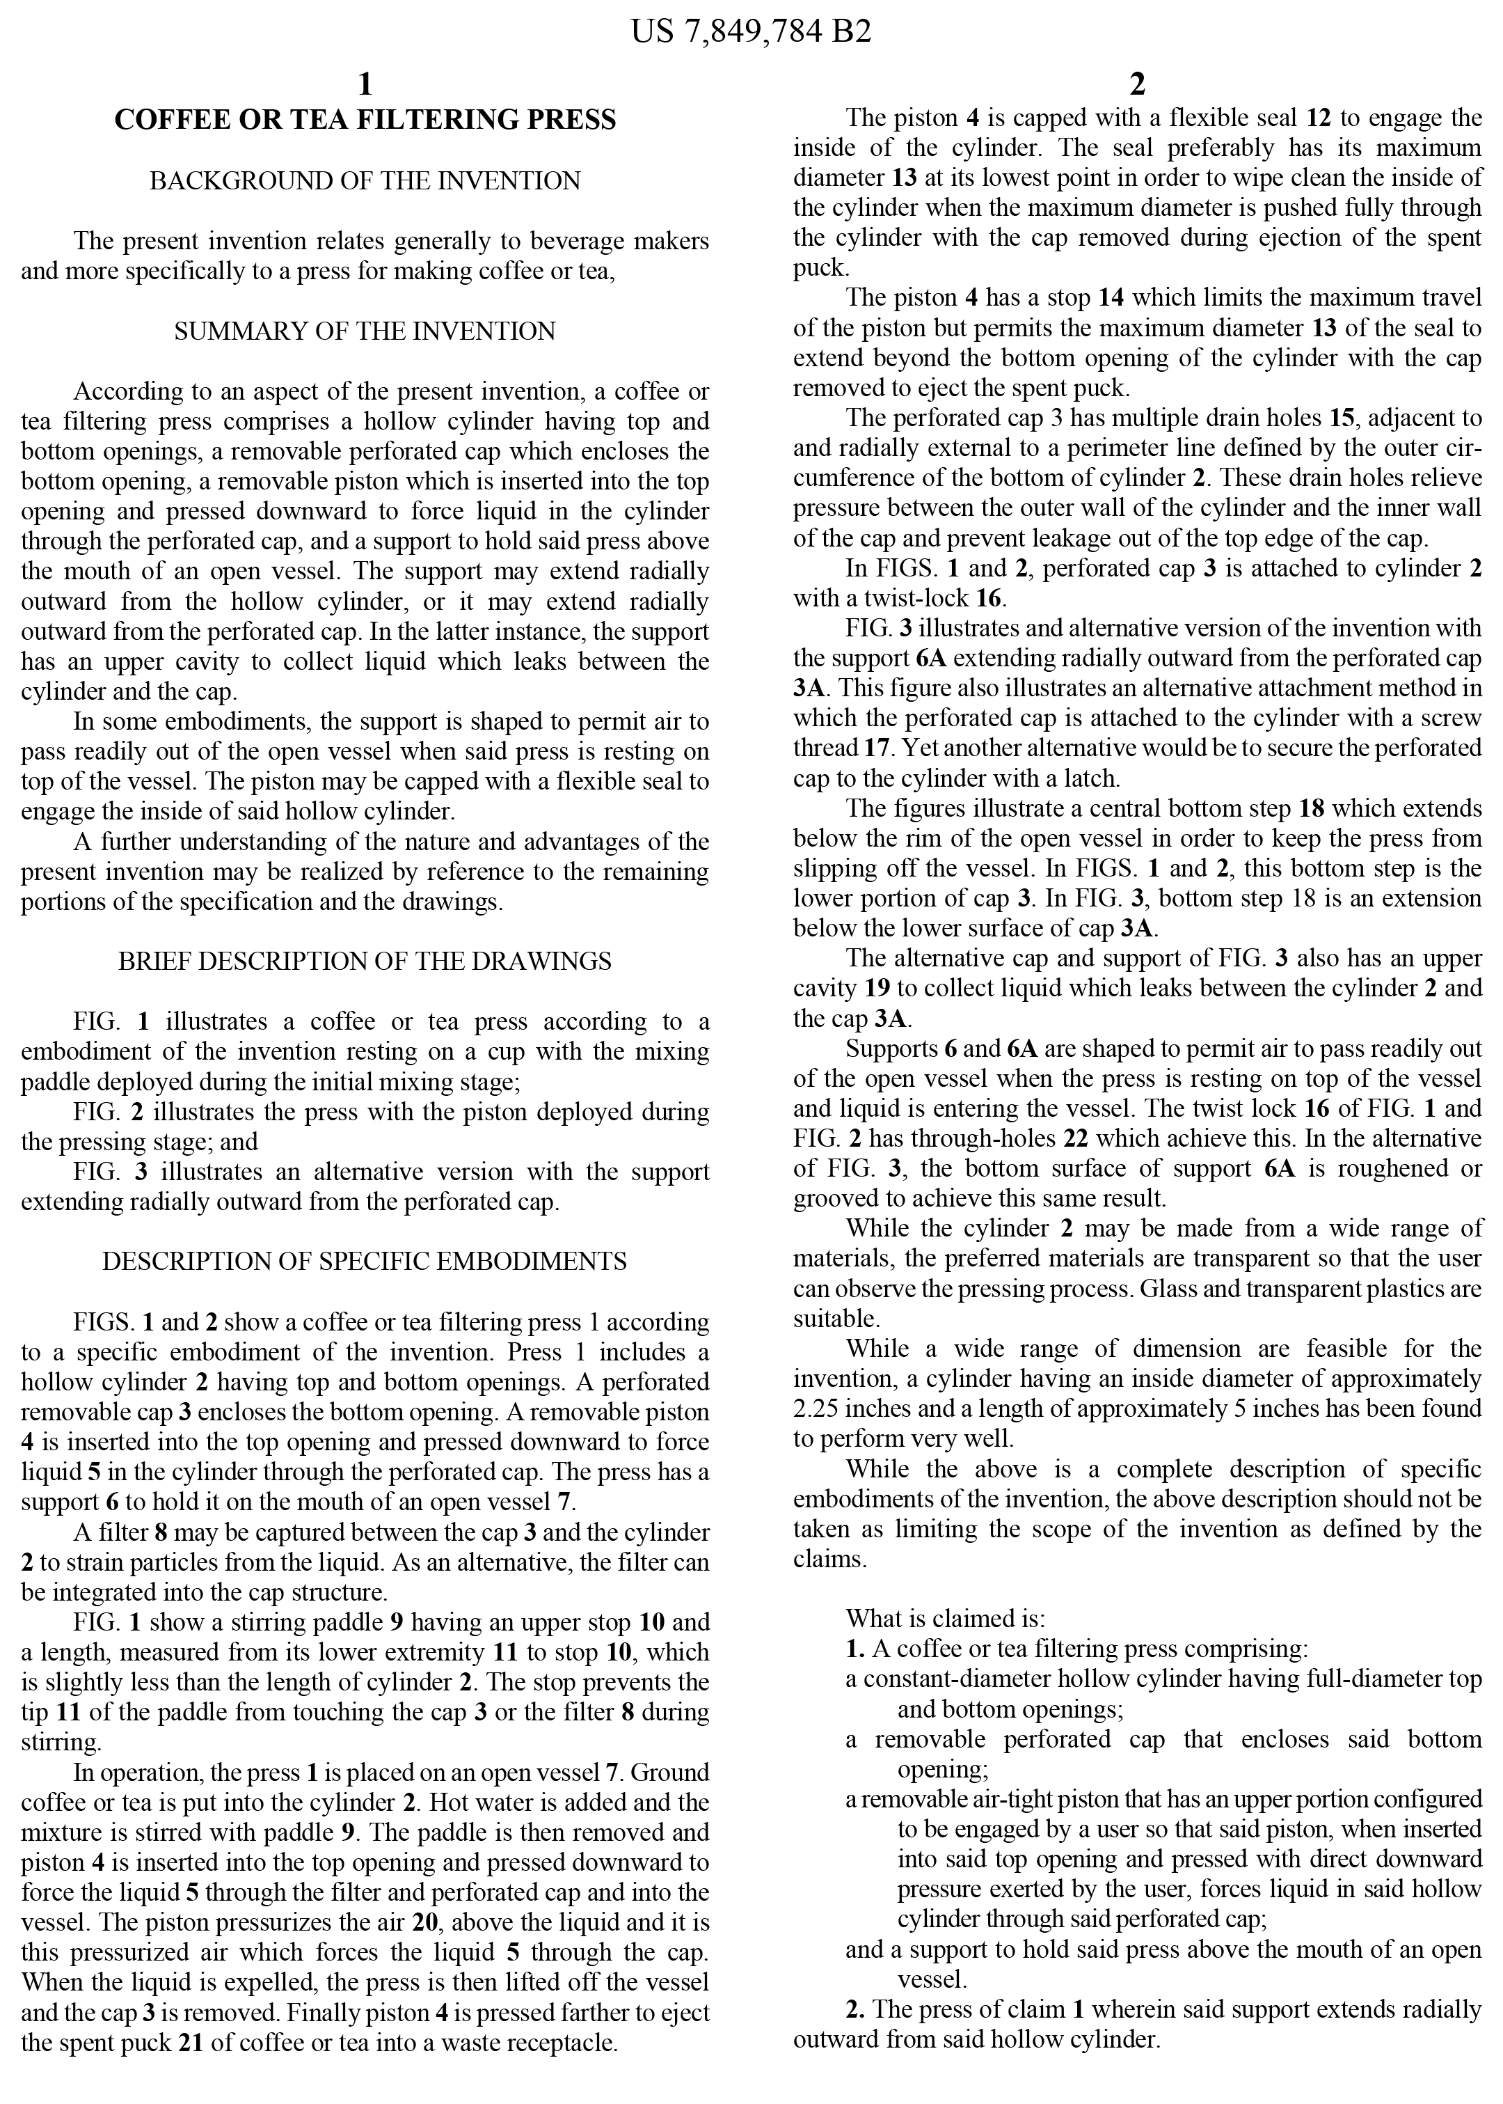

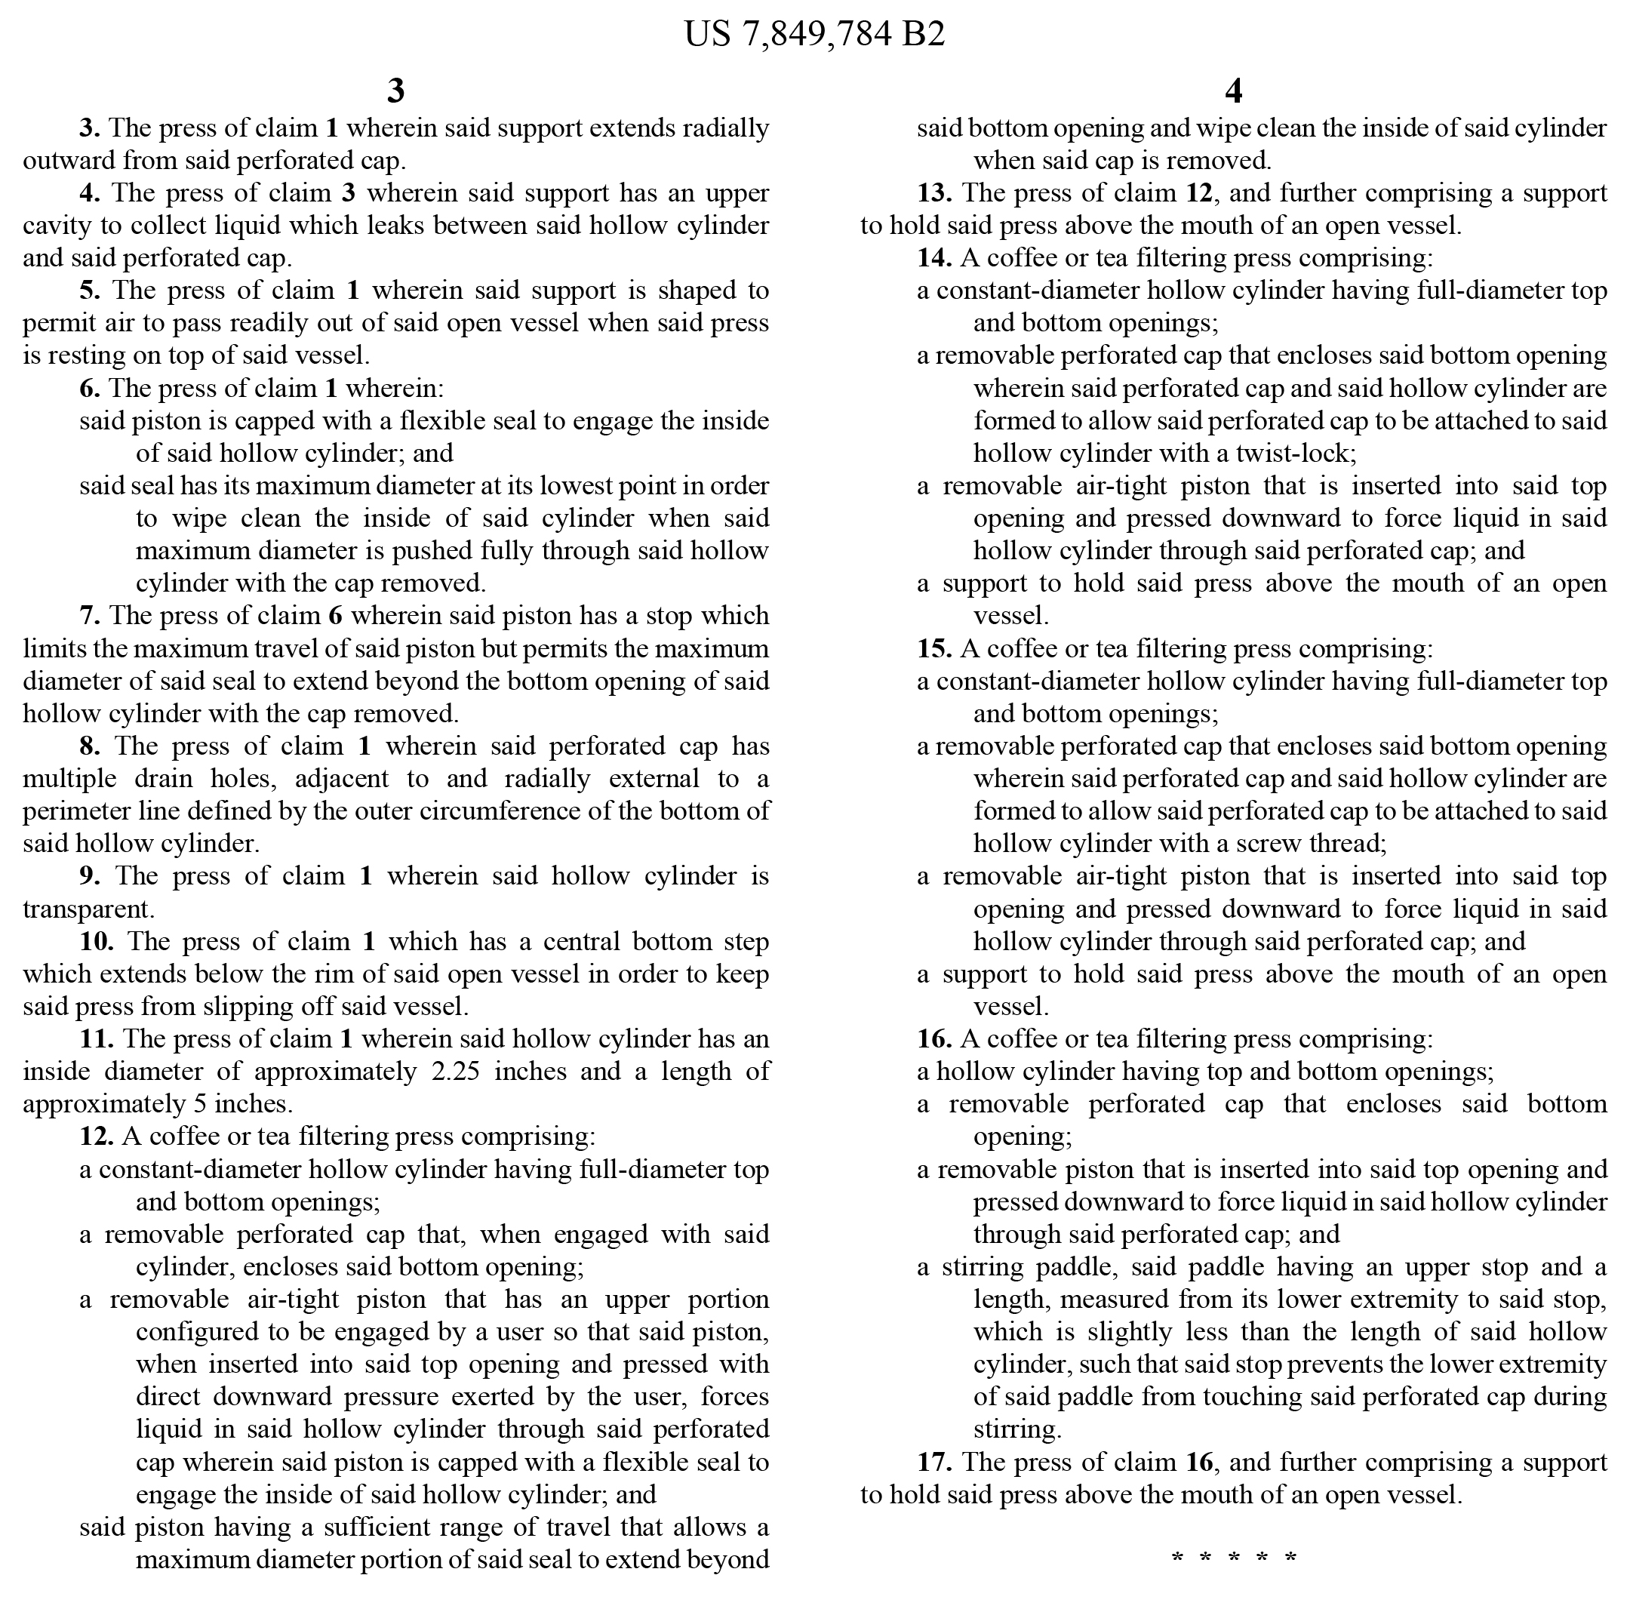

3 d.) International Patent Law
Like trademark law, patent law is territorial. Inventors must file for patents in all countries where they seek protection, and those patents will be governed by domestic laws. However, there are a number of international agreements that seek to harmonize international rules and streamline the application process. The key international agreements are the Paris Convention for the Protection of Industrial Property or “Paris Convention” (1883), the Trade Related Aspects of Intellectual Property Agreement or “TRIPS Agreement” (1994)—negotiated as part of the Uruguay Round of the General Agreement on Tariffs and Trade (GATT), and the Patent Cooperation Treaty (1970).
The Paris Convention provides for “national treatment,” meaning that participating countries must offer the same protection to patent owners from other signatories as they give to their nationals (if I patent my invention in Germany, they must give me the same rights as they give to a German inventor who patents there). In addition, the Paris Convention allows inventors to claim the initial filing date in one country as the priority date in all participating countries, as long as they file the other applications within a year. Like the Paris Convention, the TRIPS Agreement provides for national treatment and common priority dates, but it also establishes “minimum standards” for patent protection. Many of the features of our current patent law were added in order to comply with TRIPS. These include the current patent term of 20 years from the filing date, the ability to file “provisional” applications, and the exclusive rights of “offering for sale” and importation, among other provisions. The Patent Cooperation Treaty focuses on the application process, and has a series of procedures for streamlining the filing and prosecution of patent applications in multiple countries.
Before the passage of the America Invents Act, the United States was one of the few countries with a first-to-invent system. While not directly required by international treaties, our recent shift to a first-to-file system brings us into line with the predominant international standard. That said, there are still noteworthy differences between the patent laws of different nations. For example, in many other countries, inventors must file patent applications before publishing their inventions; there is no one-year “grace period” after disclosure as we have in § 102(b).
3 e.) Miscellanea
We will close with three final notes about subjects not covered in this casebook.
- Design patents and plant patents: The readings in this book focus on “utility patents,” but there are also two additional kinds of patents that are subject to different rules. Design patents can issue to “whoever invents any new, original, and ornamental design for an article of manufacture.” The invention must be ornamental rather than functional. Design patents have been granted for ornamental characteristics of items such as shoes and furniture, and they last for 15 years. §§ 171–173. Plant patents are another category that may be granted to “whoever invents or discovers and asexually reproduces any distinct and new variety of plant.” §§ 161–164. (A law outside of the scope of patent law called the Plant Variety Protection Act covers sexually reproduced plants.)
- Government patents & the Bayh-Dole Act: In the copyright context, works of the US government go into the public domain under § 105. No such limitation obtains in patent law. The Federal government owns thousands of patents. The Bayh-Dole Act, however, allows certain private entities to keep ownership of the patents stemming from Federally-funded research. The Act was prompted by the (empirically contestable) belief that this will be a greater spur to both innovation and licensing.
- Infringement and defenses: The law of patent infringement and defenses is beyond the scope of this book. The bases of patent infringement are in § 271. As you read in Sony v. Universal, unlike in copyright law, the patent statute spells out both direct and contributory infringement. Among the defenses to patent infringement are prior commercial use, including exhaustion or “first sale” (once a patented product is sold, it can be resold and repaired) § 273, patent misuse (a common law doctrine that patents will not be enforced when they have been misused by the patentee, subject to limitations in § 271(d)), and inequitable conduct. Patent has no doctrine that is equivalent to copyright’s broad and protean doctrine of fair use. For example, there was an extremely limited exception for experimental use, but its already minuscule protections were effectively rendered inconsequential by Madey v. Duke (Fed. Cir. 2002).
Note: A Patent Eligibility Flow Chart
On the next page you will find a flow chart laying out the requirements for patentability—patentable subject matter, utility, novelty and non-obviousness.
Once again, please use it in two ways; as a map of what you will be learning and a tool to help you in your analysis of the Problems.
We have stressed throughout the book that, while we think you will find the flow charts and checklists helpful, you need to understand their limitations. That warning is particularly needed in the patent section. Our book only covers the requirements for patent eligibility, leaving much of patent law unexplored. Still, even with that caveat, we hope you will find it useful.

REQUIREMENTS FOR PATENT PROTECTION
(This is a (highly) simplified preview of what you will learn and
a tool to use in the problems.)
Is the invention patent-eligible subject matter? (Chapter 18)
NOT PATENTABLE
Is it a process, machine, manufacture, or composition of matter under § 101?
YES
NO

YES
Is there an inventive concept—i.e., are there additional elements that amount to significantly more than the judicial exception? If so, granting a patent might not risk tying up the use of the underlying ideas, and the invention becomes patent-eligible. Generic computer implementation is not enough to satisfy this step.
Does it satisfy the utility
requirement? (Chapter 19)
Does it satisfy the novelty
requirement? (Chapter 20)
Does it satisfy the non-obviousness
requirement? (Chapter 21)
NO
NO
YES
YES
YES
YES
NO
NO
Is it a law of nature, natural phenomenon, or abstract idea? These are judicially created exceptions that exclude the basic tools of scientific and technological work from patent protection, keeping them free for future innovation. “Abstract ideas” include mathematical formulas, algorithms, and fundamental economic principles.
An invention cannot be patented until it has substantial, specific, and
credible utility. “Substantial” means that it has a significant and presently available benefit to the public. “Specific” means that it provides a well-defined and particular benefit to the public.
Inventions must be novel. If the invention was already patented, described in a publication, on sale, or otherwise available to the public, it is not novel. However, this is true only if every element of the invention is present—expressly, implicitly, or inherently—in a single prior art reference, and there is meaningful public access to that prior art.
If, over 1 year before filing the application, the inventor themselves makes their invention available to the public, this also defeats novelty, unless this use qualifies for the “experimental use exception.”
PATENTABLE
Inventions must be non-obvious to a hypothetical “person having ordinary skill in the art” (PHOSITA), because obvious inventions would be developed even without the patent incentive. Courts apply a 4-part test that 1) limits relevant prior art to “analogous” art, 2) ascertains differences between the claimed invention and the analogous art, 3) defines the PHOSITA, and 4) considers “secondary considerations” supporting non-obviousness such as a long-felt but unsolved need for the innovation.
NO

James Bessen & Michael J. Meurer, A Third of the Economy Is at Stake and Patent Trolls Are to Blame, Washington Post, Nov. 18, 2015, https://www.washingtonpost.com/news/in-theory/wp/2015/11/18/ patent-trolls-are-costing-us-billions-they-must-be-stopped/.
For example see, James Bessen & Michael J. Meurer, Patent Failure: How Judges, Bureaucrats, and Lawyers Put Innovators at Risk (2008); Adam Jaffe and Josh Lerner, Innovation and Its Discontents: How Our Broken Patent System is Endangering Innovation and Progress, and What To Do About It (2004).
James Bessen, Peter Neuhäusler, John L. Turner, Jonathan Williams, The Costs and Benefits of United States Patents (June 2013), Boston Univ. School of Law, Law and Economics Research Paper No. 13-24. Available at http://www.bu.edu/law/workingpapers-archive/documents/turnerjbessenjneuhauslerpwilliamsj061213.pdf.
To quote one court’s definition, a troll is a plaintiff who is “more focused on the business of litigation than on selling a product or service or licensing their copyrights to third parties. A copyright troll plays a numbers game in which it targets hundreds or thousands of defendants seeking quick settlements priced just low enough that it is less expensive for the defendant to pay the troll rather than defend the claim.” Wisser v. Vox Media Inc. (S.D.N.Y. 2020.) One law firm alone filed 1900 copyright cases between 2016 and 2019, a substantial proportion of the total.

